KITH & KIN INTERNATIONAL COLLEGE
7/11 Kaoli Olusanya Street, Owode Ibeshe, Ikorodu, Lagos State.
THIRD TERM EXAMINATION 2024/2025 ACADEMIC SESSION

NAME
SUBJECT: BASIC TECHNOLOGY |  | CLASs: J.S.S.2 | DURATION: 1 ½ HOURS
INSTRUCTION: This paper consists of two section Answer ALL questions on section A and FOUR questions on section B (question one is compulsory)
SECTION A: Objective {20 marks}

- The area of a square with side ‘S’ is given by formula _______
  - S²
  - 2S
  - S³
  - S/2
- The area of rhombus with diagonal D₁ and D₂ is given by the formula
  - ½ D₁D₂
  - D₁/D₂
  - D₁ ₊ D₂
  - D₂ – D₂
- Whhen a hole is needed to drive bolt into wood, a portable ________ is the right tool
- band saw
- drill
- sander
- miter saw
- A _______ is used to cut, shape, and form metal using a rotating cutting tool.
  - grinder machine
  - shearing machine
  - milling machine.
  - press brake
- ___________ between surfaces in contact is the primary cause of friction.
  - Smoothness
  - Adhesion
  - Lubrication
  - Weight
- _________ belts are toothed and are designed to maintain a precise speed ratio, often used in synchronous application like camshaft drive
  - V-belt
  - Flat belt
  - Timing belt
  - Round belt
- __________ gears are designed to on non-parallel, intersecting shafts, typically at right angle and come in straight, spiral and hypoid variation.
  - Helical
  - Bevel
  - Worm
  - Rack and pinion
- To remove contaiminant from hydraulic fluid and to protect the system a ________ is used.
- valve
- actuator.
- pump
- filter
- The diagram below illustrates ________ drive.
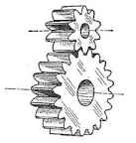
- belt drive
- chain drive
- gear drive
- dog teeth
- Ceramics are often used to make one of the following items due to their heat and electrical resistance.
  - cutlery
  - electrical insulator
  - plates
  - tiles
Use the figure below to answer question 11 to 13.
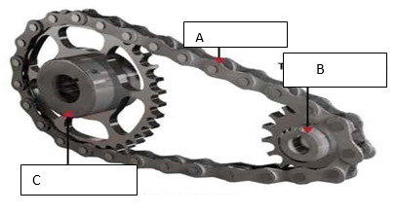
- The part labeled A in the figure shown above is
- sprocket.
- chain.
- pinion
- spur gear.
- If power from an electric motor is connected to the part marked B then
- C is the driven.
- A will transmit the power from B
- C is the driver.
- C will transmit the power through A to the other shaft.
- In figure above, an electric motor is connected to part marked X,
- the output speed will be greater than the input speed.
- the output speed will be same as the input speed.
- the output speed will be doubled.
- the input speed will be doubled.

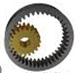
- The type of gearing shown above is called
  - bevel gearing.
  - internal gearing.
  - external gearing
  - rack and pinion gearing.
- The image shows below is a typical ______ device.
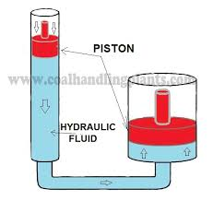
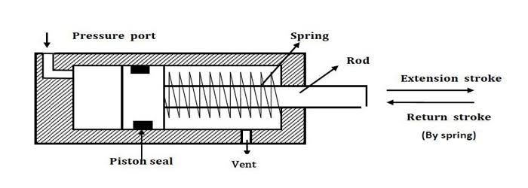
A. hydraulic
B. pneumatic
C. electronic
- automobile
- The construction below is
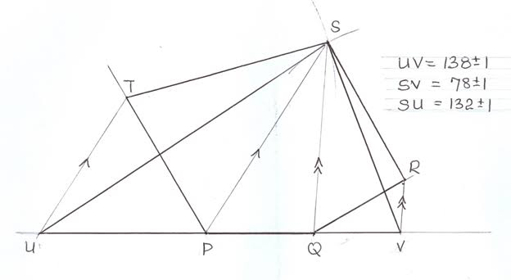
A. a rectangle equal to a regular polygon in area
B. a triangle equal in area to irregular polygon
C. a trapezium equal in area to irregular polygon
D. a triangle that is half in area to an irregular polygon
- The woodwork machine shows below is
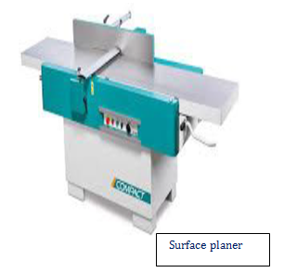
A. lathe machine
B. milling machine
C. circular saw
D. surface planer
- Site preparation includes the following EXCEPT ________
- cutting grass
- uprooting
- removal of top soil.
- laying of foundation.

- Gear drives are used for in the machine EXCEPT………
- motorcycle
- vehicle gear box
- elevator
- crane
- The figure shown above is used in pneumatic systems for
  - pumping pneumatic fluid.
  - controlling the flow of air in the system.
  - producing motion
  - none of the above

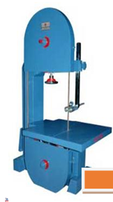
- The metalwork machine shown below is __________

  - circular saw
  - band saw
  - drilling machine.
  - hydraulic press
- The emergency exit in the workshop is for
  - entrance of workshop
  - exit of workshop after work
  - escape only
  - all purpose
- Safety is ……..
- protection of life and properties
- prevention of danger or hazard
- provision on amenities
- fighting fire
- The purpose of hydraulic fluid in a clutch system is to
  - increase and transmit the pedal force.
  - decrease and transmit the pedal force.
  - neutralize the pedal force in the transmission.
  - maintain a constant transmission system.
- A component of hydraulic machine that controls the fluid direction, pressure and fluid rate is
  - actuator
  - reservoir
  - pump
  - valve.
- Which of these statements is true when three gears of equal size are arranged as shown below?


- X rotates faster than Y
- X rotates in the same direction as Y
- X rotates in the same direction as Z
- Y rotates in the same direction as Z
- _______ is the removal of roots of trees from the site
  - Grubbing
  - Setting out
  - Excavation
  - Digging
- The removal of pants and unwanted materials on site is
- profiling
- digging
- clearance
- excavation
- A quadrilateral that has four equal sides at right angle is a/an
  - rectangle
  - square
  - deltoid
  - rhombus
- What is the ratio of a driving gear with 20 teeth that driven by 5 teeth gear?
- 1:4
- 1:5
- 1:10
- 4:1
- Which of the following is commonly referred to as a general purpose machine?
- Drilling
- Lathe
- Miller
- Planer
- The part labelled X in the drawing below represents
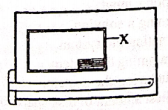
  - borderline
  - brawing board
  - drawing paper
  - Tee square
- The picture below is _______ building service.
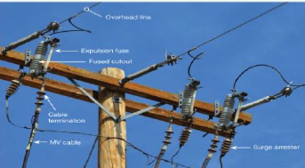

  - water
  - sanitation
  - electricity
  - drainage
- What will be the speed of rotation of a 40 teeth gear when it is driven by an 80 teeth gear at a speed of 20 rpm
- 20
- 40
- 60
- 30
- The purpose of sanitation include the following EXCEPT.
  - avoid pollution
  - keep safe environment
  - not harmful to others.
  - beautify the environment
- The construction below represents
  - construction of a triangle half in area to given parallelogram
  - construction of a triangle equal in area to a given parallelogram
  - enlarge a parallelogram to twice its size
  - construction of a similar parallelogram

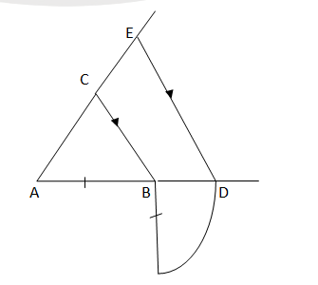
- The construction below represents

- triangle ABC with same area as ADE
- triangle ABC twice the area of ADE
- triangle ADE twice the area of ABC
- triangle ADE twice the size of ABC
- The following forces are acting on floating or flying object EXCEPT …….
- thrust
- drag
- weight
- electromagnetic
- The picture below is the process of _____ in site preparation.
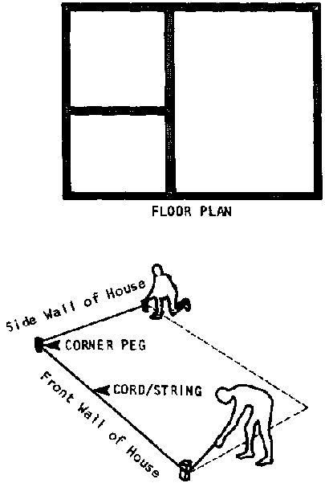
  - setting out
  - dewatering
  - extermination
  - excavation.
- The portable woodwork machine shows below is
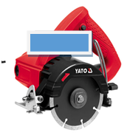
  - cutter
  - circular saw
  - power wrench
  - power screwdriver
- One of the advantages of friction is
  - wear and tears
  - increase efficiency
  - enable stoppage of mo
  - loss of energy
- One of the safety precaution during practical is
  - avoid the use of machine
  - never use cutting tools
  - obey instructions
  - wear slippers
- Which of the following is used to reduce friction?
  - Increase rough surface
  - Add lubrication
  - Increase weight
  - Stop motion
- The following are types of lubrication EXCEPT
- dry lubrication
- liquid lubrication
- solid lubrication
- theodolite lubrication
- The metalwork machine shows below is used for
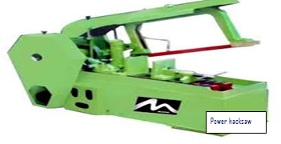
- boring holes in metals
- surfacing and threading metals
- cutting all form of metals
- joining metals
- The woodwork machine shown below is used for
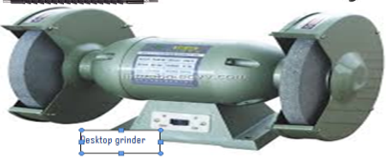
- grinding wood
- filing cutlass, saw and other cutting tools
- boring hole
- cutting circular wood
- ________ friction occurs when surfaces are in contact but not moving relatively to each other.
- Kinetic friction
- Static friction
- Fluid friction
- Air friction
- One of the following is a frictional drive.
- gear drive
- belt drive
- chain drive
- front wheel drive
- One of these cannot be produced through knowledge gains from basic technology.
- funnel
- flag
- bag
- sky
- The picture below is a.
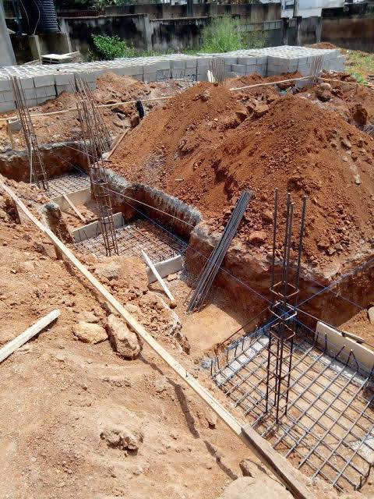
- setting out
- excavation
- grubbing
- timbering

SECTION B {40 marks}
Instruction: i. Answer FOUR questions from this section, question ONE is compulsory and any other THREE.
ii. Use all necessary drawing instruments and materials where applicable.
iii. Credit will be awarded for neatness and accuracy
iv. Use pencil for all construction questions

- A. Draw boarder lines and title block, fill in your name, school, class, subject and date (4 marks)
B. Draw freehand sketch of the following (i) crossed belt (ii) one metalwork machine (iii) two site preparation tools (6 marks)
C. Construct a parallelogram ABCD in which AB=80mm, BC =60mm and angle <ABC = 60⁰, construct a triangle equal in area to the parallelogram. (6 marks)

2. (A). Define the following i. hydraulic devices ii. Pneumatic devices iii. Belt drive iv. Gear ratio. (2 marks)
(B). List four advantages of belt drive? (2 marks)
(C) List and describe briefly four types of gears. (2 marks)
(D) Name four safety precaution for using sawing machines. (2 marks)

3. (A) Construct a square with side 40mm use it to and construct a triangle of equal area. (2 marks)
(B). Define the following i. woodwork machines ii. Metalwork machines iii. Friction iv. Site preparation (2 marks)
(C) Calculate the speed of a driven pulley of 80mm diameter when driven by a pulley of
150mm diameter at speed of 1800rev/min. (2 marks)
(D) Explain briefly four building services. (2 marks)
4. (A) Define the following i. gearing ii. Building construction iii. Wood hand drilling machine iv. Metal grinding machine (2 marks)
(B) Calculate the speed of a gear with 40 teeth driven by another gear with 20 teeth at the speed of 1200rev/min. (2 marks)
(C) Define the following i. site preparation ii. Grubbing iii. Setting out iv. Dewatering (2 marks)
(D) Write the type of belt shown below in the box provided. (2 marks)
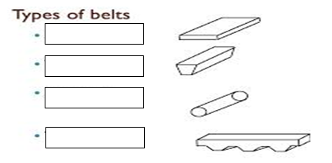

5. (A) The gear with 100 teeth rotates at 2000rev/min drives another gear with 60 teeth, calculate the speed of the driven gear. (2 marks)
(B) State four effects of friction on belt drive (2 marks)
(C) Name four examples of pneumatic system. (2 marks)
(D) List four importance of building. ( 2 marks)

